GRADE 7 ACCELERATED  Unit 1 Assessment  Equations and Inequalities ANSWER KEY | 21 points

DIRECTIONS. Show your work for every question. Write repeating decimals with a bar over the digits that repeat. Fractions do not have to be in simplest form. Where a question gives units, include them in your answer.
SCORE TRACKER
Benchmark | Questions | Possible | Earned
MA.7.NSO.1.2 | 1a–c, 2a–d | 7
MA.7.AR.2.2 | 3a–b, 4, 5, 6, 7a–b | 7
MA.8.AR.2.2 | 8, 9, 10, 11, 12a–c | 7
Total |  | 21
One point per lettered part, and one point per question that has no parts. Every part is right or it is not, so the three rows above are counts of ticks. The teacher's copy carries each question's benchmark in the right margin; the student's copy carries the point value alone.
Follow-through. If a student writes the wrong equation or inequality in one part and then works their own answer correctly in the next, the next part still earns its point. Mark the second part against what they wrote, not against the key.

1. Complete the table by writing the equivalent value in each empty cell. | MA.7.NSO.1.2  3 points

 | Fraction | Decimal | Percent
a. | 6/11 | 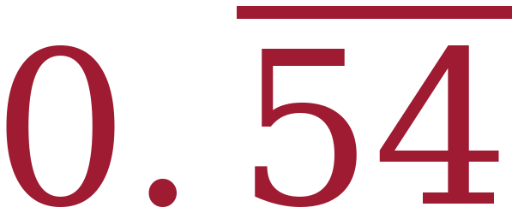 | 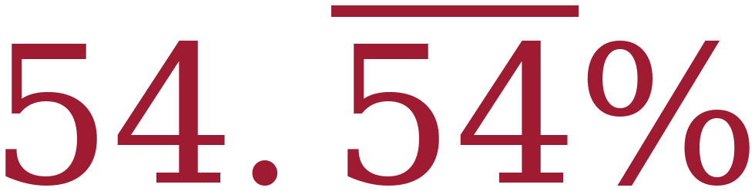
b. | 85/100 (or 17/20) | 0.85 | 85%
c. | 72/100 (or 18/25) | 0.72 | 72%

One point per row, and both empty cells in a row have to be right. Any equivalent fraction is acceptable. A repeating decimal written without the bar does not earn the row.
2. Maria opens a package of Tropical Skittles. The package has five flavors: Banana Berry (yellow), Kiwi Lime (green), Mango Tangelo (orange), Pineapple Passion fruit (blue) and Strawberry Starfruit (pink). The table shows what part of Maria's package is each flavor. | MA.7.NSO.1.2  4 points

Flavor | Amount
Banana Berry | 20%
Kiwi Lime | 4/15
Mango Tangelo | 0.12
Pineapple Passion fruit | 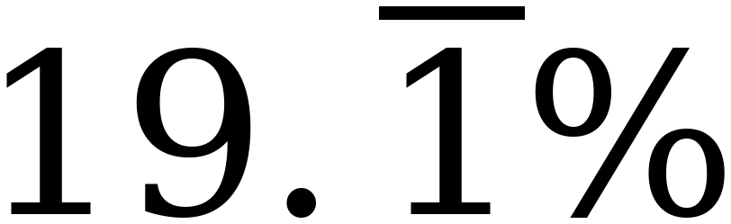
Strawberry Starfruit | 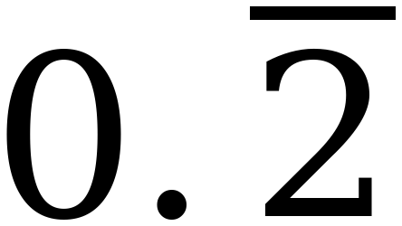

a. What percentage of Maria's package is Mango Tangelo? | MA.7.NSO.1.2  1 point

 | Percentage | 12%

b. Rewrite the amount of Maria's package that is Kiwi Lime as a decimal. | MA.7.NSO.1.2  1 point

 | Decimal | 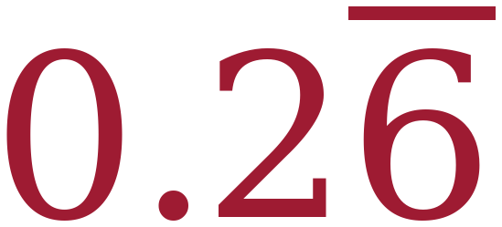

c. What fraction of Maria's package is Strawberry Starfruit? | MA.7.NSO.1.2  1 point

 | Fraction | 2/9

d. Rewrite the amount of Maria's package that is Banana Berry as a decimal. | MA.7.NSO.1.2  1 point

 | Decimal | 0.2

No partial credit on any part. 4/15 = 0.2666… so the bar goes over the 6 only. The five amounts total exactly 100%, which is a useful check to point out afterwards.
3. Esmeralda is saving for a trip to Siesta Key. She is paid the same amount every week. Each week she uses $382 of her pay for her expenses and saves everything that is left. After 11 weeks she has saved $506. | MA.7.AR.2.2  2 points

a. Write an equation that can be used to determine the amount, x, in dollars that Esmeralda is paid each week. | MA.7.AR.2.2  1 point

 | Equation | 11(x − 382) = 506

b. Solve the equation. | MA.7.AR.2.2  1 point
x − 382 = 46 (divide both sides by 11)
x = 428
Check: 11(428 − 382) = 11(46) = 506 ✓
 | Solution | x = 428, so Esmeralda is paid $428 each week
A student who writes 11x − 382 = 506 gets x = $80.73, which does not cover $382 of weekly expenses. A wrong setup is not charged twice: part b earns its point if they solve their own equation correctly.

Solve each equation. Show your work.
4. −4(w + 7) = 108 | MA.7.AR.2.2  1 point
w + 7 = −27 (divide both sides by −4)
w = −34
Check: −4(−34 + 7) = −4(−27) = 108 ✓
 | Solution | w = −34
Distributing first also works: −4w − 28 = 108, so −4w = 136 and w = −34.

5. n ÷ (−3) + 3.8 = −7.4 | MA.7.AR.2.2  1 point
n ÷ (−3) = −11.2 (subtract 3.8 from both sides)
n = 33.6 (multiply both sides by −3)
Check: 33.6 ÷ (−3) + 3.8 = −11.2 + 3.8 = −7.4 ✓
 | Solution | n = 33.6

6. 3 ⅚ = 8 ⅕ − k | MA.7.AR.2.2  1 point
Common denominator 30: 3⅚ = 115/30 and 8⅕ = 246/30
115/30 = 246/30 − k
k = 246/30 − 115/30 = 131/30 = 4 11/30
Check: 8⅕ − 4 11/30 = 246/30 − 131/30 = 115/30 = 3⅚ ✓
 | Solution | k = 4 11/30 (also 131/30)
A student who solves correctly but loses the −1 coefficient of k answers −4 11/30, and does not earn the point — the sign is the question. Any equivalent form of 4 11/30 is acceptable. As a decimal it is 4.36 with the 6 repeating, so a decimal answer needs the bar the directions ask for; 4.3666… written without it does not.

7. A server at The Main Street Grill earns $7.80 per hour plus $87.40 in tips. | MA.7.AR.2.2  2 points

a. Write an equation that can be used to determine the number of hours, h, the server worked to earn $136.15. | MA.7.AR.2.2  1 point

 | Equation | 7.80h + 87.40 = 136.15

b. Solve the equation. | MA.7.AR.2.2  1 point
7.80h = 48.75 (subtract 87.40 from both sides)
h = 6.25
Check: 7.80(6.25) + 87.40 = 48.75 + 87.40 = 136.15 ✓
 | Solution | h = 6.25 hours

8. Circle every value below that is a solution to −3x + 4 ≤ 19. | MA.8.AR.2.2  1 point

−8 | −6⅓ | −5 | −4.9 | 0 | 12.5

−3x + 4 ≤ 19 gives −3x ≤ 15, so x ≥ −5 (divide by −3 and reverse).
Solutions: −5, −4.9, 0, 12.5
One point, and the whole set has to be right — every value that belongs circled and none that does not. −5 is a solution because the symbol has the equal bar: −3(−5) + 4 = 19, and 19 ≤ 19. A student who circles −8, −6⅓ and −5 has solved without reversing — that set is the endpoint plus everything on the wrong side of it.
Solve each inequality. Show your work, then graph the solution set on the number line.
9. −11.3 > −3x − 0.5 | MA.8.AR.2.2  1 point
−10.8 > −3x (add 0.5 to both sides)
3.6 < x, so x > 3.6 (divide by −3 and REVERSE)
Check: x = 5 gives −15.5, and −11.3 > −15.5 ✓; x = 0 gives −0.5, and −11.3 > −0.5 ✗
 | Solution | x > 3.6

Open circle between 3 and 4, past halfway toward 4, shaded right. The solution and its graph are one point together — a right answer with a wrong graph does not earn it.

10. ⅔ (21 − 15x) > 76 | MA.8.AR.2.2  1 point
21 − 15x > 114 (multiply both sides by 3/2 — no reversal)
−15x > 93
x < −6.2 (divide by −15 and REVERSE)
Check: x = −7 gives ⅔(126) = 84, and 84 > 76 ✓; x = 0 gives 14, and 14 > 76 ✗
 | Solution | x < −6.2

Open circle between −7 and −6, just left of −6, shaded left. The solution and its graph are one point together.

11. −8(5x + 9) ≥ 208 | MA.8.AR.2.2  1 point
5x + 9 ≤ −26 (divide both sides by −8 and REVERSE)
5x ≤ −35
x ≤ −7
Check: x = −7 gives −8(−26) = 208, and 208 ≥ 208 ✓; x = 0 gives −72, and −72 ≥ 208 ✗
 | Solution | x ≤ −7

Closed circle at −7, shaded left. Distributing first also works: −40x − 72 ≥ 208, so −40x ≥ 280 and x ≤ −7. Only one reversal either way. The solution and its graph are one point together.

12. The drama club is renting a bus for a field trip. The bus company charges a flat fee of $260 plus $16 for each student who rides. The club has raised $1,000 and wants to take as many students as possible. | MA.8.AR.2.2  3 points

a. Write an inequality that can be used to determine the number of students, s, who can ride the bus. | MA.8.AR.2.2  1 point

 | Inequality | 260 + 16s ≤ 1,000
“Has raised $1,000” sets a ceiling, so the symbol is ≤. Accept 16s + 260 ≤ 1000. A strict < does not earn the point — it forbids spending exactly $1,000, which the club is allowed to do, and the symbol is what this part is asking for.

b. Solve the inequality. | MA.8.AR.2.2  1 point
16s ≤ 740 (subtract 260 from both sides)
s ≤ 46.25
 | Solution | s ≤ 46.25

c. How many students can ride the bus? Justify your answer mathematically. | MA.8.AR.2.2  1 point
46 students.
46 students cost 260 + 16(46) = 260 + 736 = $996, which is within $1,000.
47 students would cost 260 + 16(47) = 260 + 752 = $1,012, which is over budget.
Round DOWN — 46.25 is a maximum. A bare “46” with no arithmetic does not earn the point — part c asks them to justify it. A student who answers 46.25 students has solved correctly and not answered the question.

